DESIGN DOCUMENT AND UML DIAGRAM

DESIGN DOCUMENT WITH UML DIAGRAM

Mouna Giri

2017

## COUPON INVENTORY SYSTEM

Coupon Inventory System is designed where you can add the coupons manually or through a file. The coupons can be searched easily and we can get to know the search count of the binary and linear search. The coupons can be listed in the ascending order and most importantly it will be listed in the order based on the user’s choice.

The functions implemented in this project are:

1. Purchase Coupon

User can select the modes to input the coupons either manually or through an input file. If the user selects manual, then he/she can type the parameters of the coupon and it will be added to the array based linked list. If the user selects file, then the path of the file needs to entered and all the coupons data inside the file will be added to the array based linked list.

1. Search coupon(s)

User can search a coupon (or coupons) of a product. User can type the product name or coupon provider name and from this user entry, the entire array based linked list will searched for this coupon. It will be displayed if it was found, else “NO COUPON FOUND” message will be displayed.

The search will be done with two ways – linear search and binary search. And for the binary search, the linked list is first sorted and then binary search is performed. When both the search is performed, it displays the search count needed to find the coupon. And we notice that binary search is faster.

1. List coupons

User will input any parameter type of the Coupon [ Coupon provider name, Product name, price, discount, coupon status and expiration days]. The list in the ascending order of the coupons based on the parameter selected by the user is displayed to the user.

1. Exiting the program

DESIGN FLOW

EXECUTE THE PROGRAM

MENU IS DISPLAYED

TYPE 1 AND SELECT FILE/MANUAL TO ADD THE COUPONS

TYPE 2 AND TYPE THE COUPON TO BE SEARCHED

TYPE 3 AND TYPE THE ORDER TO BE LISTED

TYPE 4 TO EXIT

The code is written in JAVA programming language. The project has the below files:

* CollectionInterface.java
* Coupon_Inventory_System.java
* Coupon.java
* LinkedListArray.java
* ListInterface.java
* Sorted_LinkedList_Array.java

Coupon_Inventory_System.java is the main program and we run this program to start the coupon inventory system. I have implemented two interfaces Collection and list Interface. The Coupon.java stores all the attributes of the coupon. The array based linked list and array based sorted linked list are created for this project.

When the program is executed, an unsorted array based linked list is created and all the coupons are added to it. The coupons can be added through the input data file or manually.

When we select the Search coupon module, the linear search is performed for the unsorted linked list and binary search is performed on a sorted linked list. And the search count is displayed along with the message where the coupon is found or not.

When we select the list coupon module, the user is prompted to enter the parameter of the coupon on which the sort need to be done. When the parameter is entered, the sorted array list based on the choice is created and then displayed.

MENU

When the program is executed the below menu is displayed.

---------------------------------------------

WELCOME TO CS 401 COUPON INVENTORY SYSTEM

THIS IS THE MENU

---------------------------------------------

1. Purchase Coupons

2. Search Coupons

3. List of all the Coupons

4. Exit

---------------------------------------------

UML DIAGRAM

Please Zoom the image and I have also attached the JPEG image in the folder

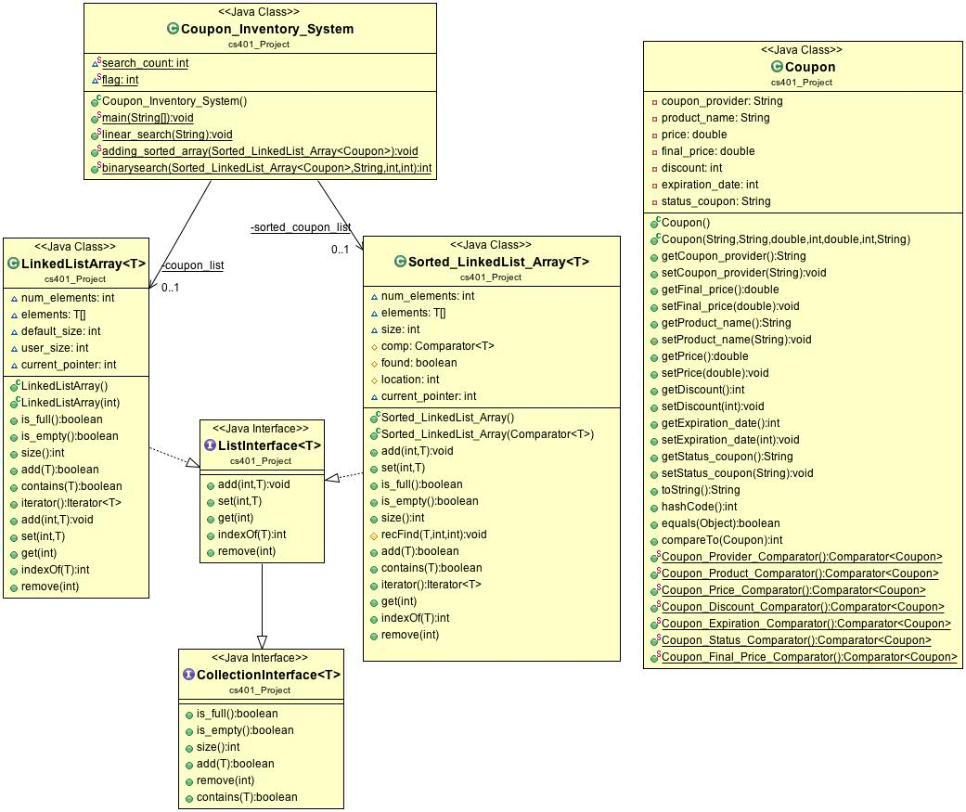

1. CollectionInterface.java

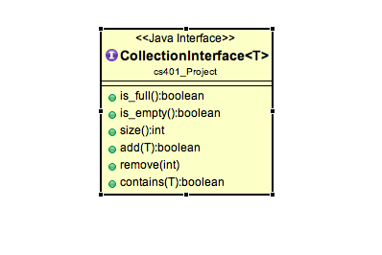

2. Coupon_Inventory_System.java

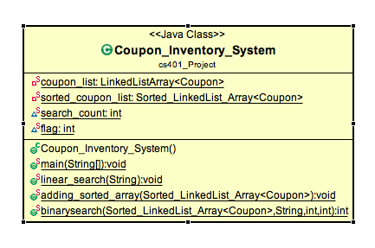

3. Coupon.java

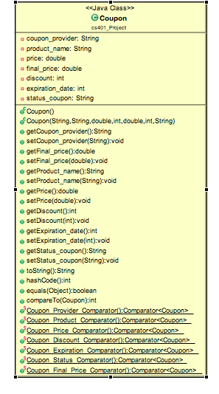

4. LinkedListArray.java

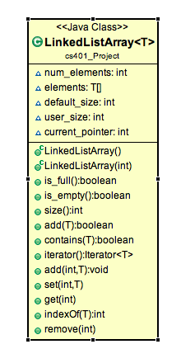

5 ListInterface.java

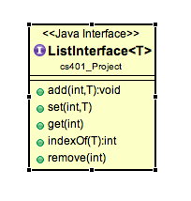

6. Sorted_LinkedList_Array.java

